Q.Write the coding to make tables by three loops.

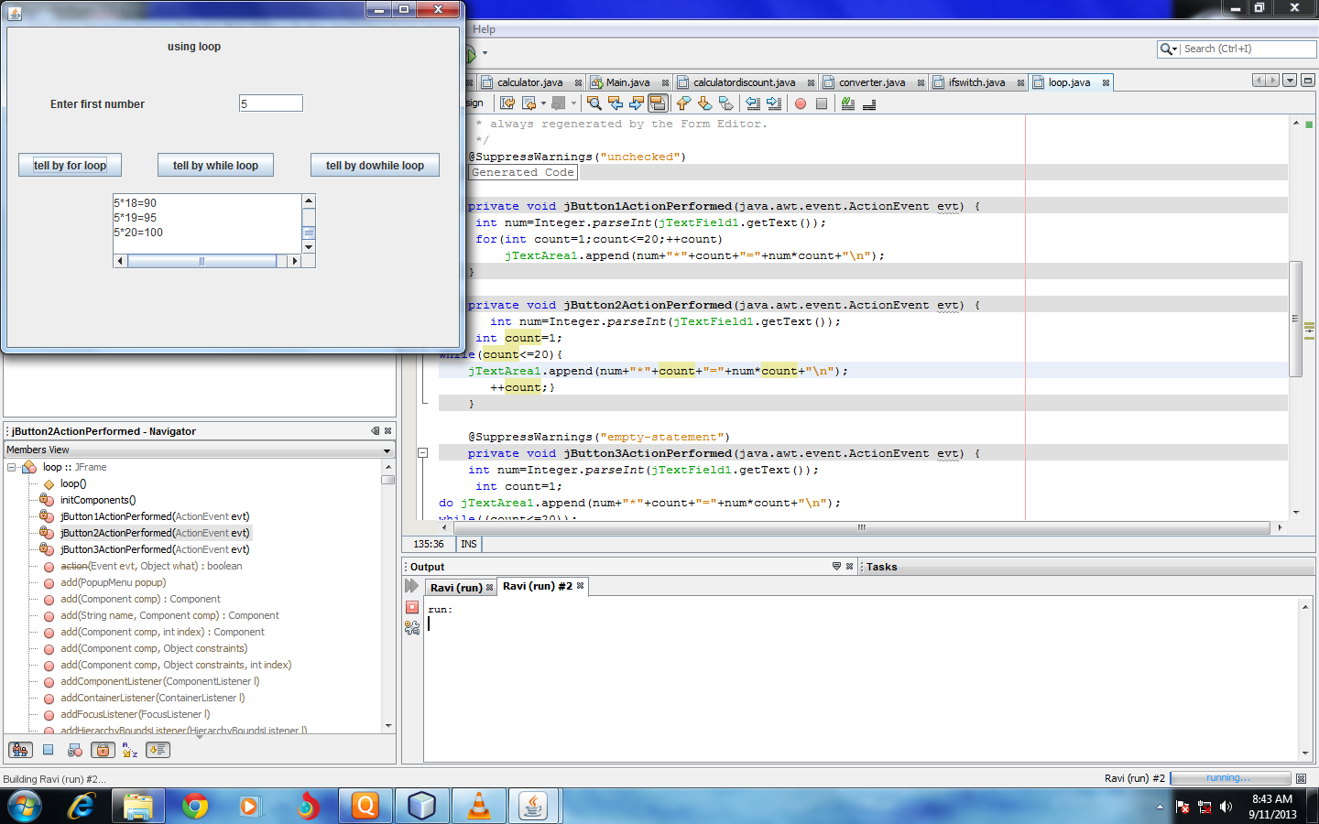

Coding---

private void jButton1ActionPerformed(java.awt.event.ActionEvent evt) {

int num=Integer.parseInt(jTextField1.getText());

for(int count=1;count<=20;++count)

jTextArea1.append(num+"\*"+count+"="+num\*count+"\n");

}

private void jButton2ActionPerformed(java.awt.event.ActionEvent evt) {

int num=Integer.parseInt(jTextField1.getText());

int count=1;

while(count<=20){

jTextArea1.append(num+"\*"+count+"="+num\*count+"\n");

++count;}

}

@SuppressWarnings("empty-statement")

private void jButton3ActionPerformed(java.awt.event.ActionEvent evt) {

int num=Integer.parseInt(jTextField1.getText());

int count=1;

do jTextArea1.append(num+"\*"+count+"="+num\*count+"\n");

while((count<=20));

}